Chemistry 260 Summer 2024

E7/T7: Selective Reduction
<< Complete this report form by inputting the information indicated by red text. Delete red text instructions before submitting (there are marks associated with doing so).>>

Name: ________________________________ Section: __________Date: ___________________________
Abstract (4 marks)
<<Delete this text and insert an abstract.>>
<<IMAGE>><<Delete this text and insert a reaction scheme showing the reaction that you performed. Recall that a scheme does not need to be balanced>>

Procedure and Observations
Procedure: (1 mark)
<<Delete this text and insert a reference to the procedure>>
Observations: (2 marks)
<<Delete this text and insert your observations for the reaction that you performed>>

Reagents and Products Tables (4 marks)
<<Insert Reagent and Product tables like in your previous reports for the reaction that you performed>>

Results
Percent Yield: (1 mark)
<<Delete this text and insert a % yield calculation for the compound you made>>
Results of IR Analysis: (6 marks)
<<You will need to add more rows to these tables. List all peaks between 4000 - 1300 cm⁻¹. Only assign major characteristic peaks. Not every peak needs an assignment or a comment. Comment on whether the assigned peaks indicate the presence of product (which one?) or of starting material. You will need to get an IR of the product you didn’t make – ask a friend!>>
Table <<X>>. ATR-IR analysis of a solid sample of the starting material, 3-nitroacetophenone.
Wavenumber (cm⁻¹) | Strength (s/m/w) | Assignment and/or Comment

Table <<X>>. <<Insert a title for a table for your reaction product’s IR spectrum>>
Wavenumber (cm⁻¹) | Strength (s/m/w) | Assignment and/or Comment

Table <<X>>. <<Insert a title for a table for your partner’s reaction product’s IR spectrum and make sure you reference them by name as the source of the data!>>
Wavenumber (cm⁻¹) | Strength (s/m/w) | Assignment and/or Comment
The raw IR spectra are attached to this report as Appendix <<X>>, <<Y>>, and <<Z>>.

¹H NMR Analysis of starting materials and potential products: (25 marks; 7 for each spectrum + 4 for predicted shifts)
<<Complete the following tables>>
Table <<X>>. NMR analysis of the starting material, 3-nitroacetophenone, in CDCl₃.
chemical shift, δ (ppm) | multiplicity | coupling constant (Hz) | integration |  | assignment | coupled to
 |  |  | actual | relative
8.77 | triplet | 2 | 1.00 | 1H
8.42 | doublet of  doublets of  doublets | 8 | 1.02 | 1H | H_{D} | H_{C}
 |  | 2 |  |  |  | H_{A}
 |  | 1 |  |  |  | H_{B}
8.29 | “doublet of triplets” | 8 | 1.02 | 1H | H_{B} | H_{C}
 |  | 1 |  |  |  | H_{A} & H_{D}
7.69 | triplet | 8 | 1.05 | 1H
7.27 | singlet | - | - | - | CHCl₃ in CDCl₃ | -
2.70 | singlet | - | 3.21 | 3H |  | -
The provided NMR spectrum and expansion are attached to this report as Appendix <<X>>.

Table <<X>>. Predicted chemical shifts for the three possible reduction products. Note: If a product contains the –CH(OH)-CH₃ group due to the ketone being reduced, the yellow pages will only include a range for the general group –CH₂X. Use a value of +0.10 for ortho, 0.00 for meta, and +0.05 for para for this assignment.
 | 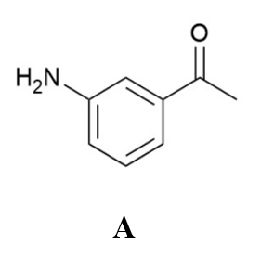 | 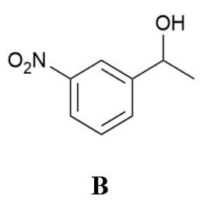 | 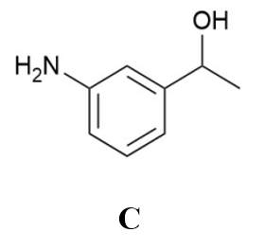
Proton | Predicted  δ (ppm) for molecule A | Predicted  δ (ppm) for molecule B | Predicted  δ (ppm) for molecule C
H_{a}
H_{b}
H_{c}
H_{d}
¹H NMR Analysis of experimentally obtained reaction products:
<<You will need to add more rows to these tables. Complete an NMR table for both reaction products (find a friend who did the opposite reaction as you and ask them to trade data). Fully assign the NMR spectrum for each product and include a labelled structure of each molecule. If you identify any impurities (from unreacted starting material, the solvent, workup, etc., include their chemical shifts, multiplicity, coupling constants, and assignments in the table.>>

<<Insert a title>>
δ (ppm) | Multiplicity | Coupling  Constant, J (Hz) | Integration |  | Assignment
 |  |  | Actual | Relative
The raw NMR spectrum and expansion are attached to this report as Appendix <<X>> and <<Y>>.

<<Insert a title>>
δ (ppm) | Multiplicity | Coupling  Constant, J (Hz) | Integration |  | Assignment
 |  |  | Actual | Relative
The raw NMR spectrum and expansion are attached to this report as Appendix <<X>> and <<Y>>.

Discussion: (25 marks; maximum 900 words)
<<Delete this text and insert your discussion. What was the product of each of the two reactions and how do you know? Be concise and do not assume the reader already knows the answers. Explain how you have interpreted your data and what it means – don’t just summarize the tables without commentary on the significance of the data.
Discuss the success/failure of the experiment, and provide analysis of the yield and purity. The discussion should include comments on potential improvements of the experiment.>>

Conclusion: (2 marks)
<<Delete this text and insert a conclusion.>>

References: (1 marks)
- <<insert your reference(s) if necessary>>

Appendices:
<<Attach your numbered appendices with titles.>>

Additional Graded Components:
Prelab: 5 marks
Samples & Clean-up: 2 marks
Appropriate editing and formatting of the report: 2 marks

